# The ITEF Model

ITEF is not a framework or a methodology but rather a reference model aimed at "Green First" in the IT field. The ITEF model is reported in the following scheme.

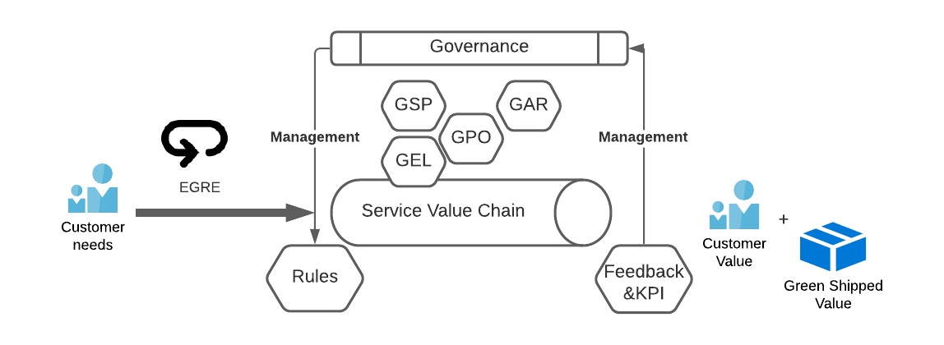

At the beginning of the process there are the Customer's needs that are treated through the demand management processes. During this phase is implemented the ITEF practice called eGre (etical Green requirement excitation) whose purpose is to support the customer in formulating needs compatible with the production of "Green First" services and who will explicate in a shared activity of backlog declutter.

E' previewed then a model of operation of the Service Provider that realizes the own Service Value adopting 4 fundamental elements of efficiencyamento Green that are:

* GEL (Green Extension of Lean): this is an extension of Lean IT (derived from the Toyota Production System) whose scope is the reduction of "green-waste" related to IT production.
* GPO (Green Production Optimization): it is a model of efficiency based on the integrated use of practices such as Agile, DevSecOps, Itil v4 whose orchestration is also optimized functionally to the goal of "Green First".
* GSP (Green Service Principles): these are principles of operation implemented consistently with the rules defined by the IT Governance.
* GAR (Green Architectural Refactoring): It is one of the main elements of the model aimed at a review of the architectural design that leads to a reduction of the ecological footprint.

ITEF also emphasizes governance that is able to provide clear rules for the entire organization. This governance is fed by constant feedback from the SVC (Service Value Chain) and its Green-KPIs.

The result of the Chain is the realization of the value for the Customer and the parallel "Green Value" obtained in terms of reduction of the relative ecological footprint linked to its production …